Survey Analysis

Radiotherapy

Table of Contents

###### Report Information

|  |  |
| --- | --- |
| Prepared for | International Atomic Energy Agency |
| Prepared by | Julian King, Kate McKegg, Andres Arau, Aaron Schiff, Martina Garcia Aisa |
| Cover image |  |
| Citation | King,J., McKegg, K., Arau, A., Schiff, A., Garcia Aisa, M. (2021). *Social and Economic Impact Assessment of the RCA Programme: Radiotherapy Case Study.* Vienna, Austria: International Atomic Energy Agency. |

## Disclaimer

The information in this document is presented in good faith using the information available to us at the time of preparation. It is provided on the basis that the authors of the document are not liable to any person or organisation for any damage or loss which may occur in relation to taking or not taking action in respect of any information or advice within this document

## Acknowledgements

The authors are grateful for the close and effective assistance of the Technical Cooperation division for Asia-Pacific (TCAP) and Technical Cooperation Division of Programme Support and Coordination (TCPC) of the International Atomic Energy Agency (IAEA), and the experts from the 22 participating countries in the the Radiotherapy Regional Cooperative Agreement (RCA): Australia, Bangladesh, Cambodia, China, Fiji, India, Indonesia, Japan, Laos, Malaysia, Mongolia, Myanmar, Nepal, New Zealand, Pakistan, Palau, Philippines, Singapore, South Korea, Sri Lanka, Thailand, and Viet Nam

# Acronyms

|  |  |
| --- | --- |
| Name | Acronym |
| Cooperative Agreement for Research | RCA |
| Radio Oncology | RO |
| Government Party | GP |
| International Atomic Energy Agency | IAEA |
| Radiotherapy | RT |
| IAEA Technical Co-operation Programme | TCP |
| Member States | MS |
| Educational /training programmes | ET |

# Main findings

* Out of the 22 countries that are part of the Regional Cooperative Agreement (RCA) for Research (Development and Training in Non-Destructive Testing (NDT) in Asia and the Pacific), 21 participated in the online survey: Australia, Bangladesh, Cambodia, China, India, Indonesia, Japan, Laos, Malaysia, Mongolia, Myanmar, Nepal, New Zealand, Pakistan, Palau, Philippines, Singapore, South Korea, Sri Lanka, Thailand, and Vietnam. **The support and cooperation of country representatives and IAEA staff during these unusual circumstances is gratefully acknowledged**.
* Out the 22 countries that are part of RCA, 18 currently act as recipients of the IAEA Technical Co-operation Programme (TCP). The other four (Australia, Japan, New Zealand, and very recently Korea) have voluntarily decided not to receive the IAEA TCP, but they work as resource countries to provide support for the IAEA TCP. **Based on this definition, the three countries that have historically acted as non-recipients (Australia, Japan and New Zealand) are excluded from the assessment of the criteria and level of performance conducted in this analysis. Given their historically non-recipient character, any assessment of the performance of RCA to accelerate and enlarge the application of NDT technologies in those countries would result in a misinterpretation of the results**.
* Across all the GPs that are part of the RCA programme, there are a total of 116 educational programmes on RT available, 3,215 Radio Oncology (RO) Departments, and 94 RO Societies. From the 17 GPs for which an educational programme is available, 15 (88%) reported that RCA’s support contributed to a great or some extent in their establishment.
* Compared to 2000, in 2020 there are 46,862 more RT specialists in all the countries that are part of RT RCA. This figure represents a growth of 231.9% in the period 2000 to 2020. And, 17 out of the 19 historically recipient countries (89%) consider that RCA contributed to certain extent to the increase of certified RT specialists between 2000 and 2020.
* In 2000, there were approximately 2,009 operational RT equipment (linear accelerators and Cobalt 60 machines) across all the GPs that are part of the RT RCA programme. By 2020, this figure has increased to 4,599 which represents a percentage growth of 128.9% between 2000 and 2020.
* Approximately, across all the GPs that are part of RT RCA, there were 753,636 more cancer patients treated using domestic RT facilities in 2020 than they were in 2020 (an increment of 120.5%). In 2000 there were 625,294 patients reported and 1,378,930 in 2020.

# Introduction

This report presents the findings of the Social and Economic Impact Assessment of Radiotherapy (RT) of the RCA in Asia and the Pacific. The data that informs the analysis was collected through an online survey that was designed and piloted in May 2021 and deployed between June and August 2021. The respondents to the survey were national experts on the field of NDT. They provided relevant information about the equipment, training centres, certified personnel, and the health and safety impacts of the RCA programme in their country.

From the 22 countries that are part of the Cooperative Agreement for Research (RCA), 21 participated in the survey: Australia, Bangladesh, Cambodia, China, India, Indonesia, Japan, Laos, Malaysia, Mongolia, Myanmar, Nepal, New Zealand, Pakistan, Palau, Philippines, Singapore, South Korea, Sri Lanka, Thailand, and Vietnam.

Figure: 1 below shows the countries that participated in this study

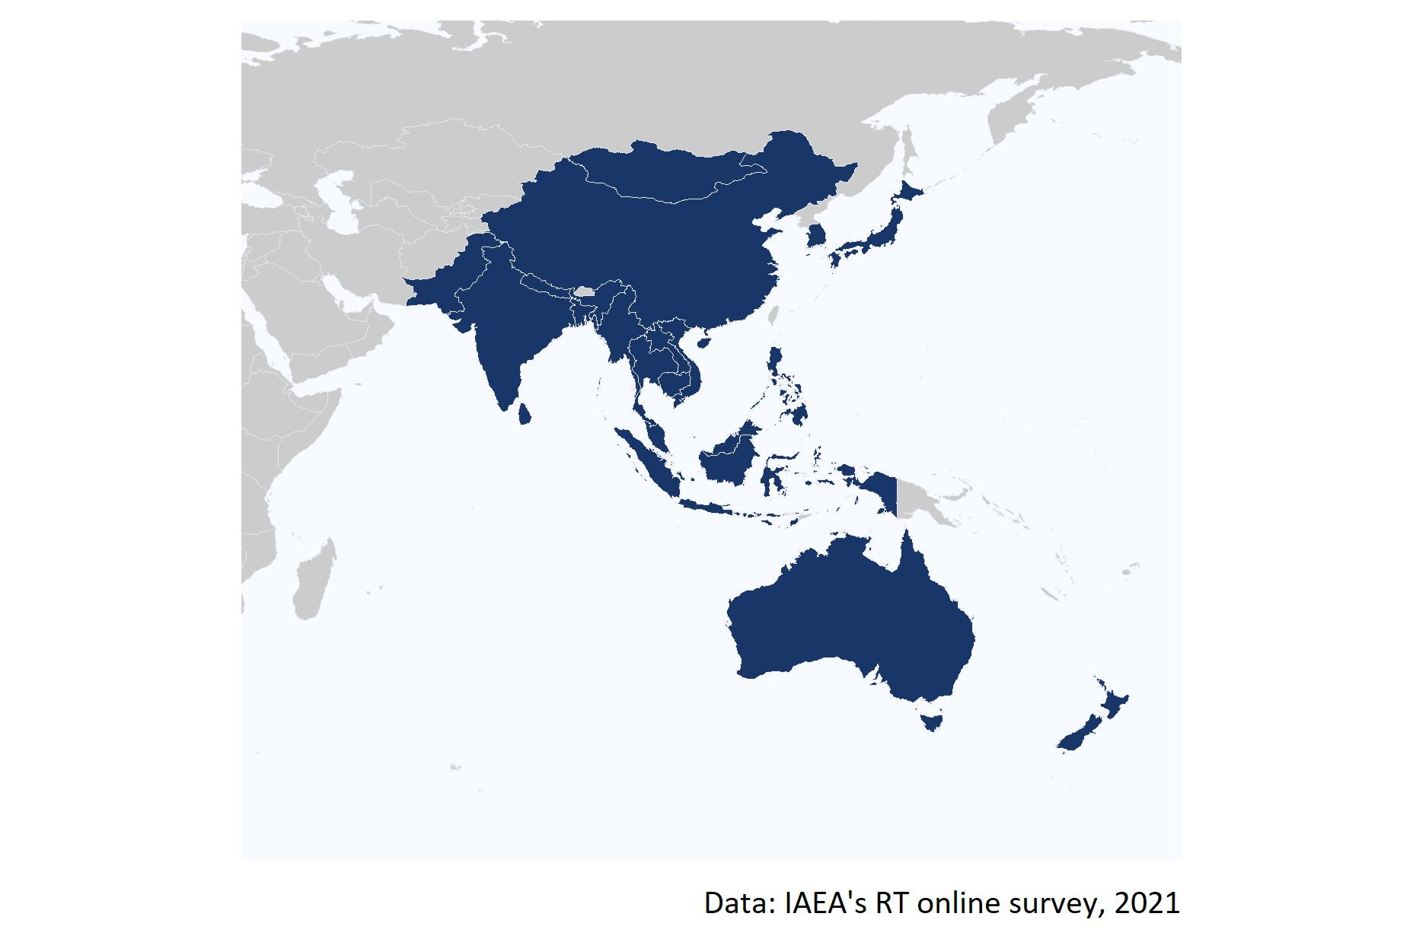

Figure 1: Map of the 20 countries that participated in the online survey.

**Strengthened radiotherapy workforce**

1. Achieve self-reliance in RT, including offering educational training programmes, and establishing Radio Oncology (RO) Departments and Societies.
2. Establish GP’s infrastructure to produce RT specialists in Radiation Oncology, Radiation Oncologists, Medical Physicists, Radiation Technology Therapists, and Radiation Oncology Nurses.

**Increased access to quality radiotherapy**

1. Increase operational RT equipment and technology
2. Increase the number and quality of treatment of cancer patients using domestic RT facilities

It is worth mentioning that the IAEA Technical Co-operation Programme (TCP) has been established by the IAEA to support IAEA Member States (MSs) (especially developing countries) to accelerate and enlarge the application of nuclear technologies in a safe, secure, effective, and efficient manner. In principle, every IAEA MS can receive and enjoy the benefit of the IAEA TCP. However, some MSs (especially developed/advanced MSs) volunteer not to receive the IAEA TCP, but they work as resource countries to provide support for the IAEA TCP. Under the RCA, there are 22 countries, of which 18 countries are TC recipients and 4 are TC non-recipients (Australia, Japan, New Zealand, and very recently Korea). **Based on this definition, the three countries that have historically acted as non-recipients (Australia, Japan and New Zealand) are excluded from the assessment of the criteria and level of performance conducted in this analysis. Given their historically non-recipient character, any assessment of the performance of RCA to accelerate and enlarge the application of NDT technologies in those countries would result in a misinterpretation of the results.**

# Criterion 1: Strengthened radiotherapy workforce

To understand the contribution of the RT RCA programme to developing the capacity and capability of the Government Parties (GPs) to strength their radiotherapy workforce, this section presents the results of the assessment of the extent to which the support of the RT RCA has enabled GPs to:

**Strengthened radiotherapy workforce**

1. Achieve self-reliance in RT, including offering educational training programmes, and establishing Radio Oncology (RO) Departments and Societies.
2. Establish GP’s infrastructure to produce RT specialists in Radiation Oncology, Radiation Oncologists, Medical Physicists, Radiation Technology Therapists, and Radiation Oncology Nurses.

Key indicators and results of this assessment are summarized in the below table

Key evidence for criterion 1: Strengthened radiotherapy workforce

|  |  |  |
| --- | --- | --- |
| Sub-criterion | Evidence | Finding |
| Achieve self-reliance in RT | Total educational/training programmes on RT available | 116 |
| Achieve self-reliance in RT | Total Radiation Oncology (RO) Departments | 3,215 |
| Achieve self-reliance in RT | Total Radiation Oncology (RO) Societies | 94 |
| Establish GP’s infrastructure to produce RT specialists | Approximate number of RT specialists in 2020 | 67,068 |
| Establish GP’s infrastructure to produce RT specialists | Increase of RT specialists between 2000 and 2020 | 231.9% |

## Criterion 1.1 Achieve self-reliance in RT

To have an approximation of the level of self-reliance in RT of each GP to strength its radiotherapy workforce, the number of educational/training programmes on RT, Radiation Oncology (RO) Departments, and RO Societies that are available in country was estimated.

#### Educational training programmes

As can be seen in Figure 2, **there are a total of 116 educational/training programmes (ET) on RT available across all the Radiotherapy RCA’s GPs**. Vietnam and China are the countries where more training programmes on RT are available (20), followed by South Korea and Japan where 15 and 10 ETs are available.

According to the responses of the GPS, there are none training programmes on RT available in Cambodia, Laos, Palau, and Sri Lanka.

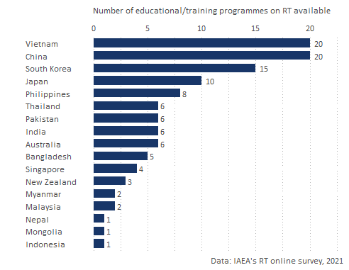

Figure 2: Number of educational or training programmes on RT available by GP.

#### Radiation Oncology Departments

**There a total of 3,215 Radiation Oncology (RO) Departments across all the GPs**. From all those departments 45.5% are located in China, 22.9% in Japan, and 15.6% in India. Figure 3 shows the number of RO Departments available in each GP.

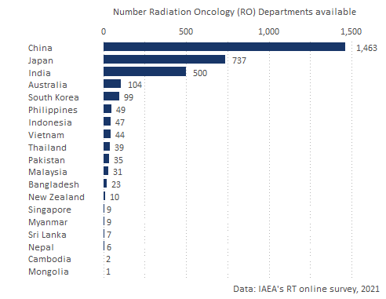

Figure 3: Number of educational or training programmes on RT available by GP.

#### Radiation Oncology Societies

**Accros all the GPs there are a total of 94 Societies from which 64.9% are regional societies**. The countries with the largest number of societies are China (39), India (14) and Japan (5). Australia, Mongolia, Myanmar, Nepal, New Zealand, Sri Lanka, Thailand, and Vietnam have societies at the national level but not at the regional one.

Figure 4 shows the number of national and regional RO societies estanlished accross the GPs.

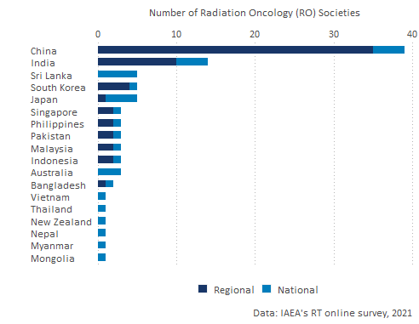

Figure 4: Number of Radiation Oncology (RO) Societies available by type and by GP.

## Criterion 1.2 Establish GP’s infrastructure to produce RT specialists

**In 2020 there were, approximately, a total of 67,068 RT specialists across all the GPs that are part of RT RCA, from which 75.7% were certified specialists**. The country with more RT specialists is China with 44,721 specialists followed by India and Japan who have trained 7,003 and 6,656 specialists respectively.

**The method for which more specialists have been trained is Radiation Oncologists with about 30,088 specialists trained on RT**. Figure 5 shows the total number of RT specialist by GP and the proportion of specialists that are certified in 2020.

*Australia, India, Laos, Myanmar, and New Zealand did not report, during the online survey, whether their RT specialist are certified or not. Thus, their figures are coded as “Unknown” in the Figure below*.

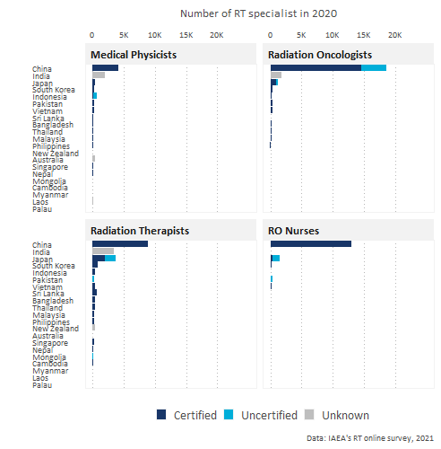

Figure 5: Number of RT specialists by GP.

#### RT specialists in 2000 and 2020

As can be seen in Figure 6, that shows the distribution of specialists by method and by country, **across all the GPs, there are 46,862 more RT specialists in 2020 than they were in 2000. This figure represents a growth of 231.9% for this period**. In absolute terms, the country with a higher growth of total RT specialists is China (30,524 new specialists) . However, in terms of proportional growth, Pakistan is the GP with a fastest growing number of RT specialist (707.1% more in 2020 compared to 2000).

India, Laos, and New Zealand reported that they did not have RT specialist in 2000 but that they have managed to produce specialists ever since.

Figure 6 below shows the growth in number of RT specialist in each GP since 2000.

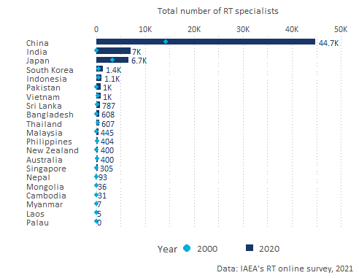

Figure 6: Number of RT specialists by GP.

#### RT specialists by method

Figure 6 shows the distribution of **certified** specialists by method and by GP in 2020 (*to make the distribution of specialists easier to read, the Figure excludes China because it has a much larger number of specialists than the rest of the GPs)*. As can be seen in the figure, **after China, the country with the highest number of Radiation Therapists (RT) specialists is Japan (about 2,000 specialists in this field)**, followed by South Korea (750). Japan is also the GP with the highest number of certified Oncologists (899).

*The countries for which the box is coded in gray is because they did not report whether their specialists are certified or not*.

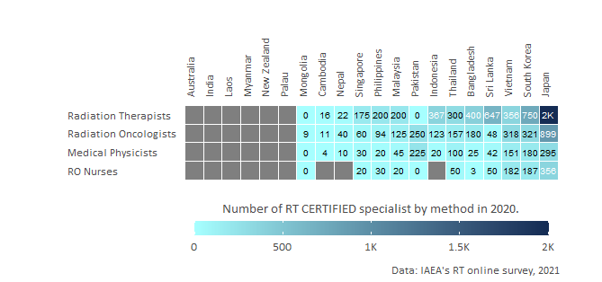

Figure 7: Number of RT specialists by GP.

## Contribution of RT RCA in strengthening ratiotherapy workforce

To assess the contribution of RCA in the establishment of training programmes, RO departments, RO societies, and the production of RT specialists the participants of the online survey were asked the extent to which they perceive that the RCA has contributed to the establishment of this infrastructure in their countries. The main findings in this respect are the following:

* **From the 17 GPs for which a training programme is available in their countries, 8 (47%) reported that RCA contributed to a great extent in their establishment, and 6 that RCA’s support contributed to some extent**. 2 countries reported that the training programmes could had been available even without the support from RCA, one of this countries is New Zealand which is a non-recipient country.
* 73% of the GPs where an RO Department has been established reported that RCA somehow contributed to its establishment. **Cambodia, China, Philippines, Sri Lanka, and Vietnam reported that RCA contributed to a great extent in the establishment of their RO departments.** Only Mongolia, New Zealand, and Singapore perceived that RCA has not contributed to the establishment of their RO departments.
* China, Japan, Mongolia,Philippines, and Sri Lanka, Vietnam reported that RCA contribution was key to the establishment of their RO societies.
* 9 out of the 19 historically recipient countries that participated in the survey (Laos, Cambodia, Myanmar, Indonesia, Japan, Malaysia, Sri Lanka, Mongolia, and Philippines) reported that RCA contributed to a great extent in the production of RT specialists. And 6 of these 19 countries perceived that RCA contributed somehow to produce their specialists. Thus **17 out of the 19 historically recipient countries (89%) consider that RCA contributed to the increase of certified RT specialists between 2000 and 2020**.
* Only Australia, Palau, and New Zealand did not report that RCA has contributed somehow to the strengthening of their RT workforce. Australia and New Zealand have acted historically as non-recipients, and Palau joined RT RCA in 2019.

The detailed contribution of RCA to the GP’s self-reliance can be seen in Figure 8.

*The labels within the boxes represent the total number of training programmes, RO departments, RO societies, and RT specialists that each GP reported for the 2020 period. The empty squares in the chart indicate that those GPs did not provide information to the online survey for either about their perception of RCA’s contribution in that dimension*

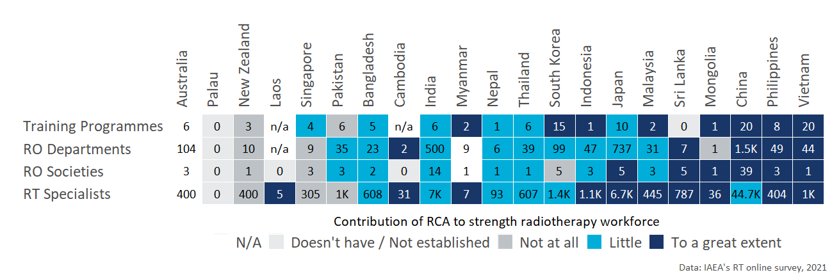

Figure 8: RCA contribution to strength radiotherapy workforce

# Criterion 2: Increased access to quality radiotherapy

This section presents the findings on the contribution of the RT RCA programme to the Increased access to quality radiotherapy in the GPs that are part of the programme and that participated in the online survey. In particular, the objective of the analysis is to understand the number of operational RT equipment and technology available, the quality of radiotherapy treatment, and the extent to which the support of the RT programme has contributed to:

1. Increase operational RT equipment and technology
2. Increase the number and quality of treatment of cancer patients using domestic RT facilities

Key indicators and results of this assessment are summarized in the below table

Key evidence for criterion 2: Increased access to quality radiotherapy

|  |  |  |
| --- | --- | --- |
| Sub-criterion | Evidence | Finding |
| Increase operational RT equipment and technology | Total number of operational RT equipment (linear accelerators and Cobalt 60 machines) in 2020 | 4,599 |
| Increase operational RT equipment and technology | % increase in the number of operational RT equipment (linear accelerators and Cobalt 60 machines) between 2000 and 2020 | 128.9% |
| Increase the number and quality of treatment of |  |  |
| cancer patients using domestic RT facilities | Total number of cancer patients treated using domestic RT facilities in 2020 | 1,378,930 |
| Increase the number and quality of treatment of |  |  |
| cancer patients using domestic RT facilities | % increase in the number of cancer patients treated using domestic RT facilities between 2000 and 2020 | 120.5% |
|  |  |  |

## Criterion 2.1 Increase operational RT equipment and technology

**In 2000, there were approximately 2,009 operational RT equipment (linear accelerators and Cobalt 60 machines) across all the GPs that are part of the RT RCA programme**. By 2020, this figure has increased to 4,599 **which represents a percentage growth of 128.9% between 2000 and 2020**. China is the country where more operational RT equipment is available (2,087 machines), followed by Japan that has 936 RT machines, and India (513 linear accelerators and Cobalt 60 machines). Palau is the only country that reported not to have any operational RT equipment available in their country.

The largest total increase in treatment machines in the period 2000 to 2010 was reported by China that reported a total increase of 1,091 in this period. However, in terms of relative terms, the largest increase was observed for Vietnam which reported to have 733.3% more RT equipment in 2020 in relation to 2020.

Figure 9 shows the total number of operational RT equipment (linear accelerators and Cobalt 60 machines) available by GP in 2000, 2010, and 2020.

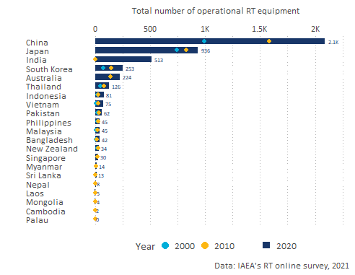

Figure 9: Total number of operational RT equipment by GP (linear accelerators and Cobalt 60 machines) by GP between 2000 and 2020.

## Criterion 2.2 Increase the number and quality of treatment of cancer patients using domestic RT facilities

Approximately, across all the GPs that are part of RT RCA, **there were 753,636 more total number of cancer patients treated using domestic RT facilities in 2020 than they were in 2020 (an increment of 120.5%)**. In 2000 there were 625,294 patients reported and 1,378,930 in 2020.

In 2020, across all the GPs, China was the country where more cancer patients were treated using domestic RT facilities (600,000 patients), followed by Japan (235,892 patients), and Pakistan (110,000).

Figure 10 shoes the total number of cancer patients treated using domestic RT facilities by GPs between 2000 and 2020.

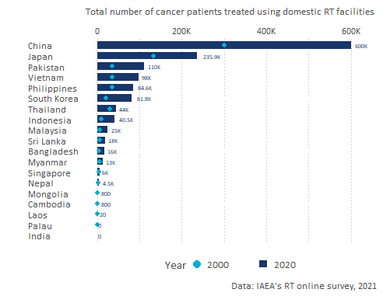 patients *roster pat (pat_num)* by year waiting times *roster wait_2000prop and 2020prop*

## Contribution RCA on Supplied RT technology and quality of treatment

#### On technology

new technologies *tech* (multiple select)

Did the RCA RT cause to invest in additional RT equipment between 2000 and 2020? By RT equipment we mean linear accelerators and Cobalt 60 machines.(*mach_rca*). From those, the additional RT equipment can be attributed to country’s participation in the RCA RT (*mach_rcanum*)

#### on patients

In your opinion, to what extent did the RCA RT programme contribute to this increase of patients treated between 2000 and 2020 *pat_cont* (extent to increase small - large) — (show graph of increase of patients and label the cont.)

In your opinion, has the quality of RT services offered in %country% improved as a result of participating in the RCA RT programme? *qual_yn* (yes/no) by how much *qual_cont* (frequency)

waiting_time : *wait_cont* (likert)

# Criterion 3: Increased life span and quality of life

# Overall impact of the RT RCA programme

# Annex A: Criteria and standards

|  |  |
| --- | --- |
| **Standard applied to each GP** | **Criterion 1: Improved NDT capacity and capability** |
| **Excellent** (exceeding expectations)    GPs with excellent status meet the standard for Good, plus: | **GPs have fulfilled the MRA requirements of ICNDT** as a result of the support under the RCA programme of IAEA.   * NDT Society is registered with APFNDT and ICNDT * The society is a signatory to ICNDT MRA * NCB for NDT accredited to ISO 17024 * NCB accepted for registration under the ICNDT MRA * Accredited training centres offering ISO 9712 training.   The support in establishing GPs’ NDT infrastructure through the RCA programme has enabled **GPs to produce *certified personnel in advanced techniques (RT-D, PAUT, TOFD, PEC, etc)*, in addition to the conventional methods (RT, UT, MT, PT, ET).**  GPs have achieved increased self-reliance in NDT, including offering training and inspection activities to local industries as well as abroad. |
| **Good** (meeting expectations)  GPs with good status meet the standard for Adequate, plus: | **GPs have established internationally-recognised NDT infrastructure at the national leve**l as a result of the support under the RCA programme of IAEA.   * NDT Society has been established * National certification body on NDT has been established. * Local NDT training centres are offering ISO 9712 training   The support in establishing GPs’ NDT infrastructure through the RCA programme has enabled **GPs to produce certified personnel in all levels of NDTs’ *five main methods* (RT, UT, MT, PT, ET)** through the national NDT certification scheme.[^Since most national certification schemes started late compared to other certification, acceptance is the main challenge.]  GPs have local NDT training centres and inspection companies offering services to local industry. |
| **Adequate** (meeting bottom-line expectations) | GPs have established **basic NDT infrastructure at the national level** as a result of the support under the RCA programme of IAEA.  National certification scheme has been established and there are **certified personnel produced by the national NDT certification scheme, however, for limited method(s) and not for all 5 main methods.**  There are trained personnel at the GP organisation level.  GPs have training centres and inspection companies, owned by foreign entities. |
| **Inadequate** | The level of NDT infrastructure is below the standard for Adequate |

|  |  |
| --- | --- |
| **Standard applied to each GP** | **Criterion 2: Increased scope and scale of NDT demand and use** |
| **Excellent** (exceeding expectations)  GPs with excellent status meet the standard for Good, plus: | From the involvement in the RCA programme, **GPs have managed to support the utilisation of the technology by industry and disseminate the knowledge developed through R&D** by publishing research articles, organising international and national seminars and conferences.  **Participation in the RCA programme results in GPs applying NDT technology in the industrial sectors for the QA and QC of industrial components** - achieving better controlled manufacturing, lower production costs, ensuring material quality, and/or greater product integrity. |
| **Good** (meeting expectations)  GPs with good status meet the standard for Adequate, plus: | From the involvement in the RCA programme, **GPs have successfully applied the NDT technology to local industry, and established R&D activities**.  **Participation in the RCA programme results in GPs becoming more concerned and interested, and starting to apply NDT technology** in the industrial sectors for the QA and QC of industrial components. |
| **Adequate** (meeting bottom-line expectations) | From the involvement in the RCA programme, **GPs have successfully managed to train personnel in the introduced technology**.  **Participation in the RCA programme of IAEA results in GPs initiating activities to create awareness** among industrial organisations about the benefits of NDT technology for QA and QC. |
| **Inadequate** | Any of the standards for Adequate are not met. |

|  |  |
| --- | --- |
| **Standard applied to each GP** | **Criterion 3: Improved health and safety** |
| **Excellent** (exceeding expectations)  GPs with excellent status meet the standard for Good, plus: | As a result of participation in the RCA program of IAEA, **GPs have been applying NDT technology** in the industrial sectors as set by countries’ industrial laws for the QA and QC of industrial components - **resulting in  improved health and safety outcomes** (i.e. fewer deaths and injuries) and/or reduced environmental pollution. |
| **Good** (meeting expectations)  GPs with good status meet the standard for Adequate, plus: | Participation in the RCA program of IAEA results in **GPs applying NDT technology for safer operation** of nuclear and other industrial installations. |
| **Adequate** (meeting bottom-line expectations) | Participation in the RCA program of IAEA results in **GPs becoming more aware of the benefits of NDT technology for safer operation** of nuclear and other industrial installations. |
| **Inadequate** | Any of the standards for Adequate are not met. |